Page1
To,
M/s. ITCLTD
P.B.NO: 2277 THIRUVOTRIYUR,
CHENNAI –600 019 TAMILNADU - India

Kind Attn : Mr. Sundareswaran.P -Engineering Department
Sub: Offer for Nidec Uni Drive
Ref No: Telephone discussion D a t e 16/06 /2025

Dear Sir,
We thank you for the discussions between us & With reference to the above, we are submitting our final most competitive offer as required by you. Please kindly accept our offer

S.No | Description | Qty | Unit PrIce | Total Price
01 | Nidec Uni Drive Model : M701 5.5 kW 400 V | 1 No | Rs. 1,12,500.00/- | Rs. 1,12,500.00/-

For any Technical clarifications please contact the undersigned
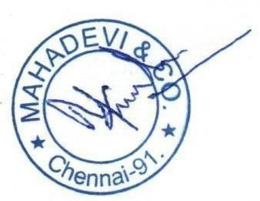
Thanks & Regards,

Yours Faithfully,
M.kumaravelan (M.D)+91-9444201021

General Terms and Conditions

Prices

GST : Extra @ 18% (HSN CODE : 84044090)
Packing and Forwarding : Nil Validity :30Days

Page2

Terms of Payment

100% against Delivery 30 Days Immediate

Note : PAYMENT 30 DAYS FROM THE DATE INVOICE , MSME CATACORY & if any mechanical erection Delay or Field Delay happen ,Insist of situation Not Hold our Payment , kindly clear our payment from the date of invoice .

Delivery

Delivery 10 weeks .

Warranty

12 months

For any Technical clarifications please contact the undersigned

Thanks & Regards,
Yours Faithfully,
M.kumaravelan (M.D)+91-9444201021

